The laboratory work 11

Exercise 1: Create a 4X2 integer array and Prints its attributes
Note: The element must be a type of unsigned int16. And print the following Attributes:
- The shape of an array.
- Array dimensions.
- The Length of each element of the array in bytes.
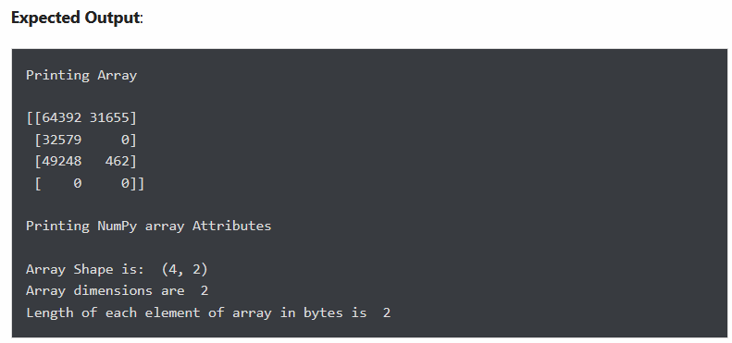

Exercise 2: Create a 5X2 integer array from a range between 100 to 200 such that the difference between each element is 10
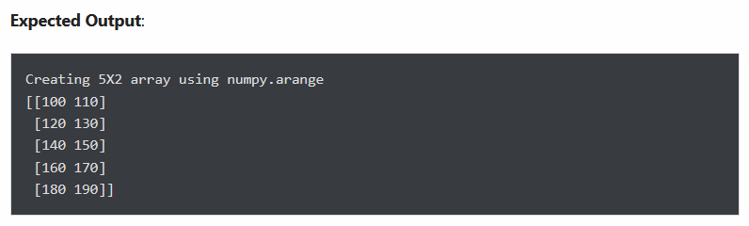

Exercise 3: Return array of odd rows and even columns from below numpy array
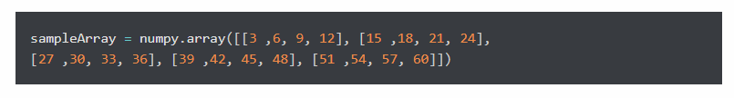
Expected output
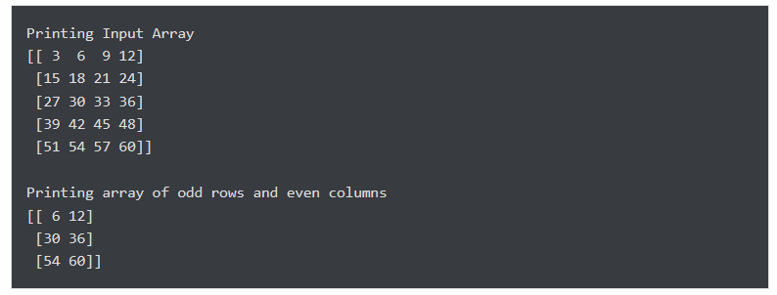

Exercise 4: Create a result array by adding the following two NumPy arrays. Next, modify the result array by calculating the square of each element
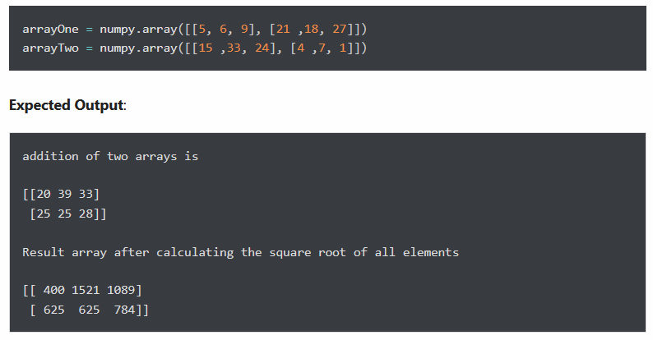

Exercise 5: Split the array into four equal-sized sub-arrays
Note: Create an 8X3 integer array from a range between 10 to 34 such that the difference between each element is 1 and then Split the array into four equal-sized sub-arrays.
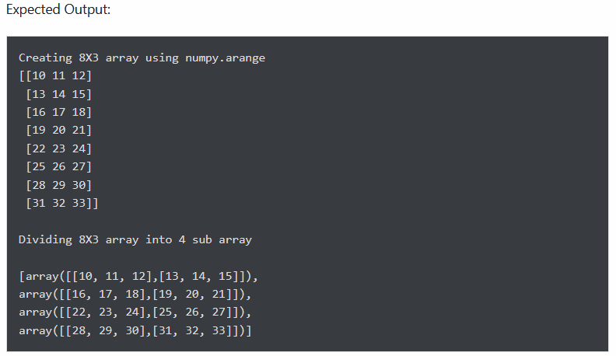

Exercise 6: Print max from axis 0 and min from axis 1 from the following 2-D array.

Exercise 7: Delete the second column from a given array and insert the following new column in its place.
